Enjoy Food?

Want to win $100?

What would

YOU

Put in School Lunches?

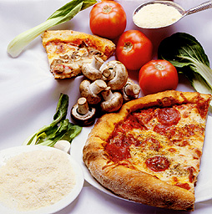

Now’s your chance to Choose!

To enter, propose a menu for a cafeteria lunch that:
- Can easily be prepared in a school kitchen
- Incorporates sustainably grown local ingredients
- Meets nutritional standards (The Institute of Medicine)
- Is DELICIOUS!
- Promote your menu on a poster with your name and HR


Contest entry forms in 025

Submission Deadline Friday April 9

Voting In Lunches Thursday April 15

Part of BLS Youth CAN’s initiative to promote sustainable habits with food

http://www.blsyouthcan.org

